This is an exponential function, which means as you increase xx, yy increases exponentially. The initial amount is given by the value aa, which is easy to see (just let x=0x=0x=0 and you have y=ay=ay=aleft). The growth factor is the value bb.

If you restrict b such that 0<b<10<b<10<b<1, the function will decay (represented below) and if b>1b>1b>1, the function will grow.

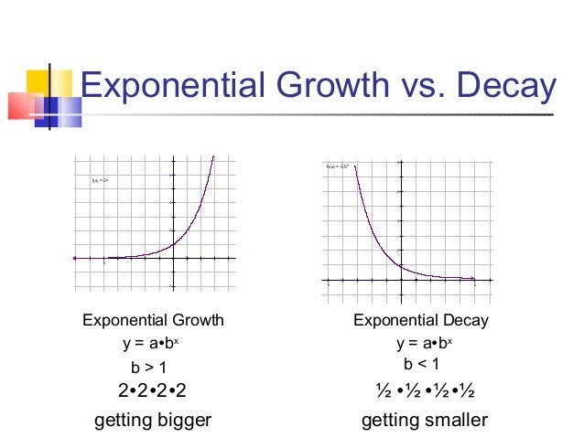

The Codomain and Range are both on the output side, but are subtly different.

The Codomain is the set of values that could **possibly** come out. The Codomain is actually **part of the definition** of the function.

And The Range is the set of values that **actually do** come out.

Example: we can define a function ***f(x)=2x*** with a domain and codomain of integers (because we say so).

But by thinking about it we can see that the range (actual output values) is just the **even**integers.

So the codomain is integers (we defined it that way), but the range is even integers.

The Range is a subset of the Codomain.

**Why both?** Well, sometimes we don't know the ***exact*** range (because the function may be complicated or not fully known), but we know the set it ***lies in*** (such as integers or reals). So we define the codomain and continue on.